**LES QUADRILATERES**

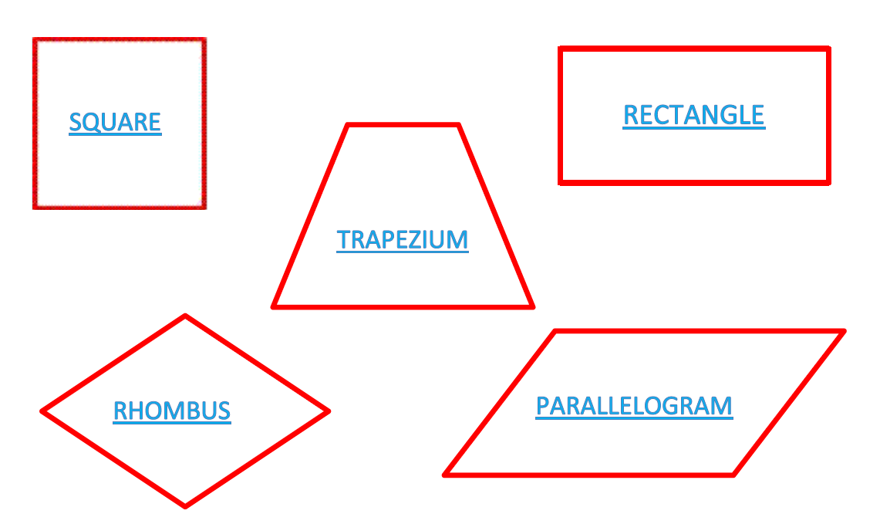

ISOSCELES TRIANGLE

*(Un parallélogramme)*

*(Un losange)*

*(Un carré)*

*(Un rectangle)*

*(Un trapèze)*